***Suspicious Human Activity and Fight Detection using Deep Learning.***

Mr. Digambar Kauthkar1,

Ms. Snehal Pingle2

1 G.H. Raisoni Institute of Engineering &Technology, Wagholi, Pune

2 G.H. Raisoni Institute of Engineering & Technology, Wagholi, Pune

1dskauthkar@gmail.com

2snehalp2000@gmail.com

Mr. Vijay Bansode3

Ms. Pooja Idalkanthe5, prof. Sunita Vani5

3 G.H. Raisoni Institute of Engineering & Technology, Wagholi, Pune

4 G.H. Raisoni Institute of Engineering & Technology, Wagholi, Pune

5 G.H. Raisoni Institute of Engineering & Technology, Wagholi, Pune

3bansodevijay97@gmail.com 4poojaidalkanthe@gmail.com

***Abstract –* With the increasing number of shootings, knife attacks, terrorist attacks etc. in public places across the world, identifying the wrong behavior of human activities in public places has become an important task. This paper focuses on a deep learning approach to detect suspicious human activity and fight using convolutional neural networks from images and videos. We analyze different CNN architectures and compare their accuracy. We design our systems that can process video footage from cameras in real time and predict whether activity is suspicious or fight found or not. We also propose future developments that can be undertaken to detect and counter distrustful human activity in the public region.**

***Keywords –* Recognizing human suspicious activity, Fight detection, [*CNN Model, Deep Learning*].**

1. INTRODUCTION

Suspicious human activity detection and fight detection from giving video as an input to system active research area of ​​image processing and computer vision. Through visual monitoring, human activities as well as human use fight can be monitored in sensitive and public areas such as railway stations, Colleges airport, shopping malls, banks, schools and bus Stop etc. To prevent terrorism, theft, accidents and illegal parking, sabotage, fighting, chain snatching, crime and other suspicious activities like fight recognizing. Public places are very difficult to see continuously, so there is a need for intelligent video surveillance that can monitor human activities classify the normal activity abnormal activities; And it can generate the alert and also send message to admin.

We are planning to build an application to detect suspicious activity and to detect fight of people in public places in real time. Our application can be used in public places like airports, Colleges, railway stations etc. where there is a danger of shooting or fire attack. We will use deep learning and neural networks to train our system. Its real-life applications range from gaming to AR/VR, healthcare and gesture recognition. Compared to the image data domain, the implementation of CNN in video classification requires relatively little work.

1. PREVIOUS APPROCH

Human suspicious activity is one of the major problems of computer vision that has been studied for more than 15 years. This is important due to the sheer number of applications that may benefit from suspicious activity. For example, Human suspicious activity is used in applications including video surveillance, human motion tracking and behavior comprehension, sign language detection, advanced human-computer interaction, and marker low motion capturing. Low-cost depth sensors have limitations such as those limited to indoor use, and their low resolution and noisy depth information make it difficult to estimate human pose \\from depth images. Therefore, we use neural networks to avoid these problems.

Suspicious human activity detection and fight detection from surveillance video is an active research area of computer vision and image processing.

1. METHODOLOGY

This system was to decide how suspicious activities to focus on. We selected suspicious activities and Fight to classify: Shooting, punching, kicking, knife attack and sword fight, gun fire. These activities formed classes for our classifier model. After the classification of All Activities to collect data for each of the classes. Photos / Images were collected from Google Images. After we collected images, we can manually filter images we take only relevant images. This was repeated for each of the module. After from that image we try to detect human suspicious activity and send mail to registered email id.

1. SYSTEM ARCHITECTURE

The Block diagram or System architecture is divided into 2 phases: training and deployment.

During the training phase, the model is trained with our custom dataset. We divide the dataset training and validation sets. Validation set contained the images which were randomly chosen from the dataset.

After the training phase, the model is built for the security teams in public places which is deployed as Desktop app. Our system is created for a desktop pc App take as input form camera as a video and it checks already stored video from the computer. This video is then preprocessed the model outputs if the video contains any suspicious activity or not. If a any misbehavior found in the video, the model produced an alert on the system and also sends an message alert on the registered email address and text along with images of the video where suspicious activity is running.

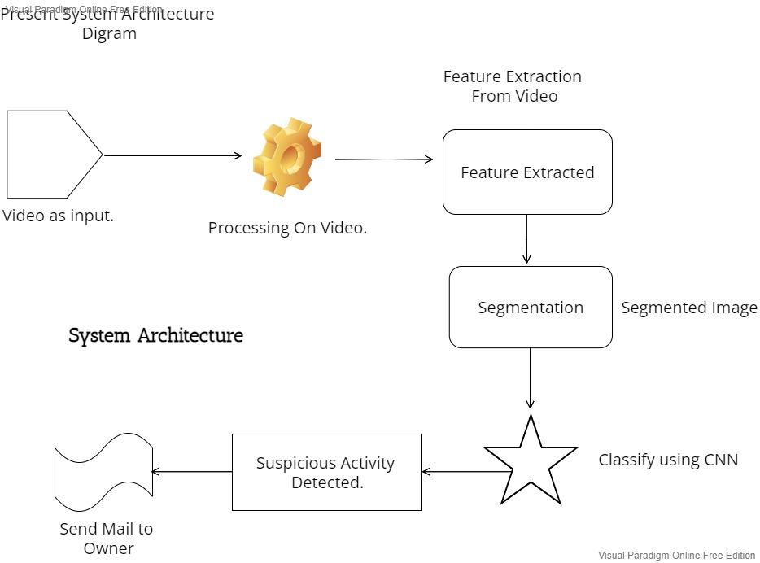

**SYSTEM ARCHITECTUR**

1. RESULT

Suspicious activity detection and fight detection have become an important area of ​​study due to the increasing number of crimes. We studied existing methods and offered an alternative approach to trace suspicious activities and fighting using CCTV footage taking place in public places. Our approach used CNN to ascertain whether activity was distrustful. In our model the detection rate is increases up to the 90 % accuracy then previous model.

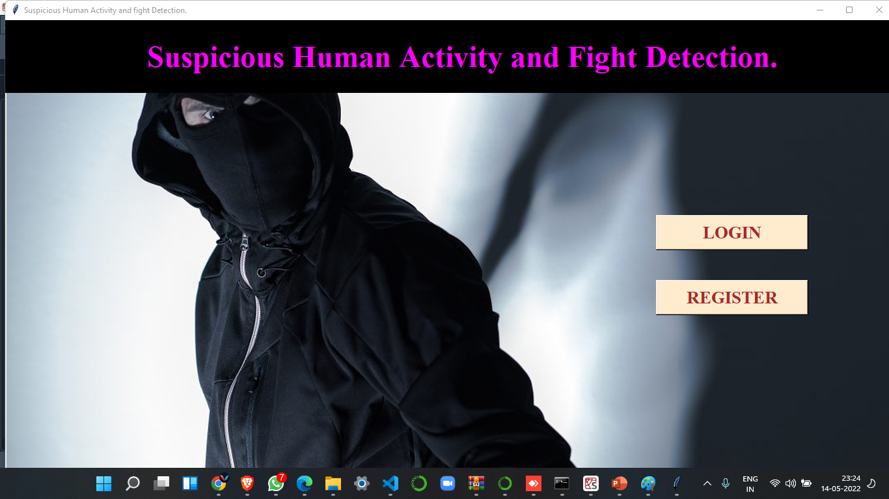

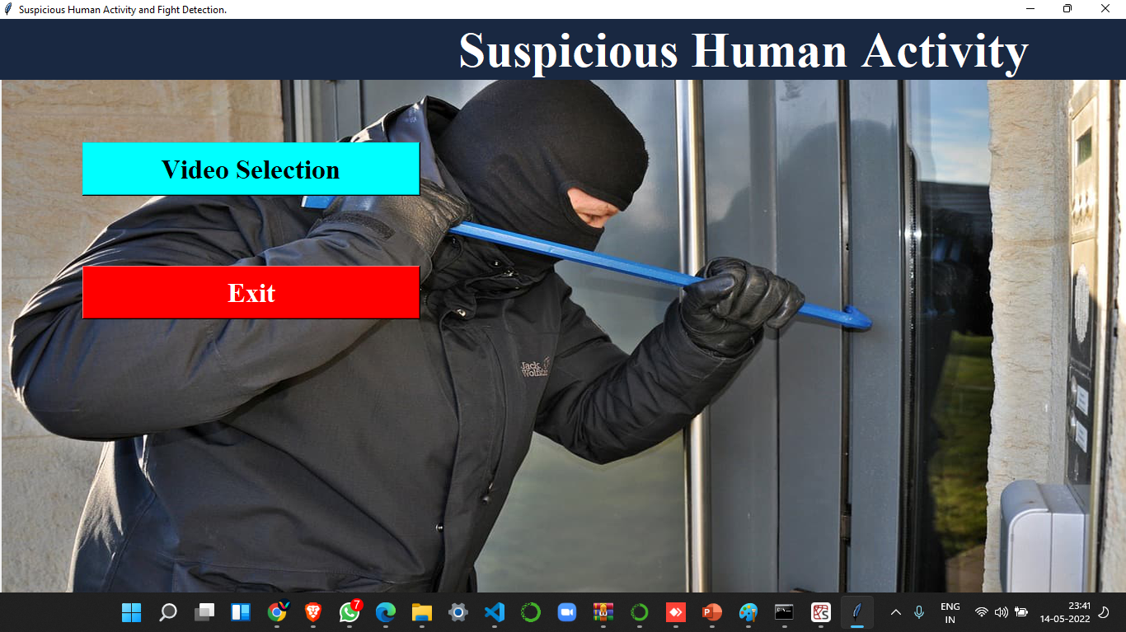

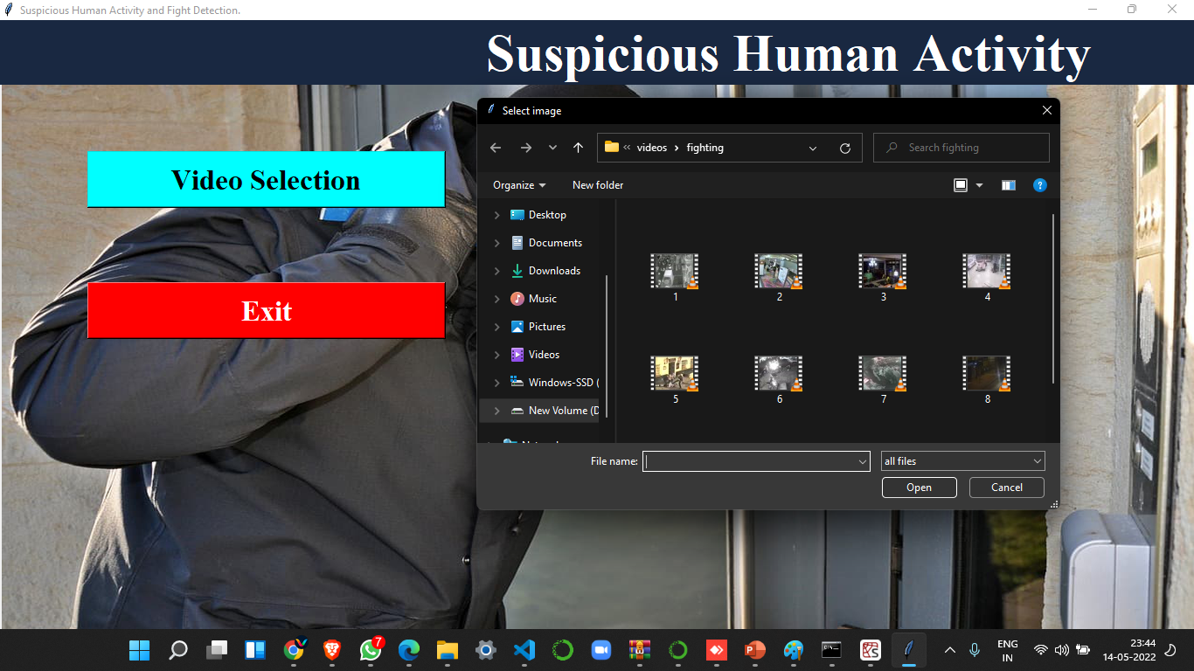

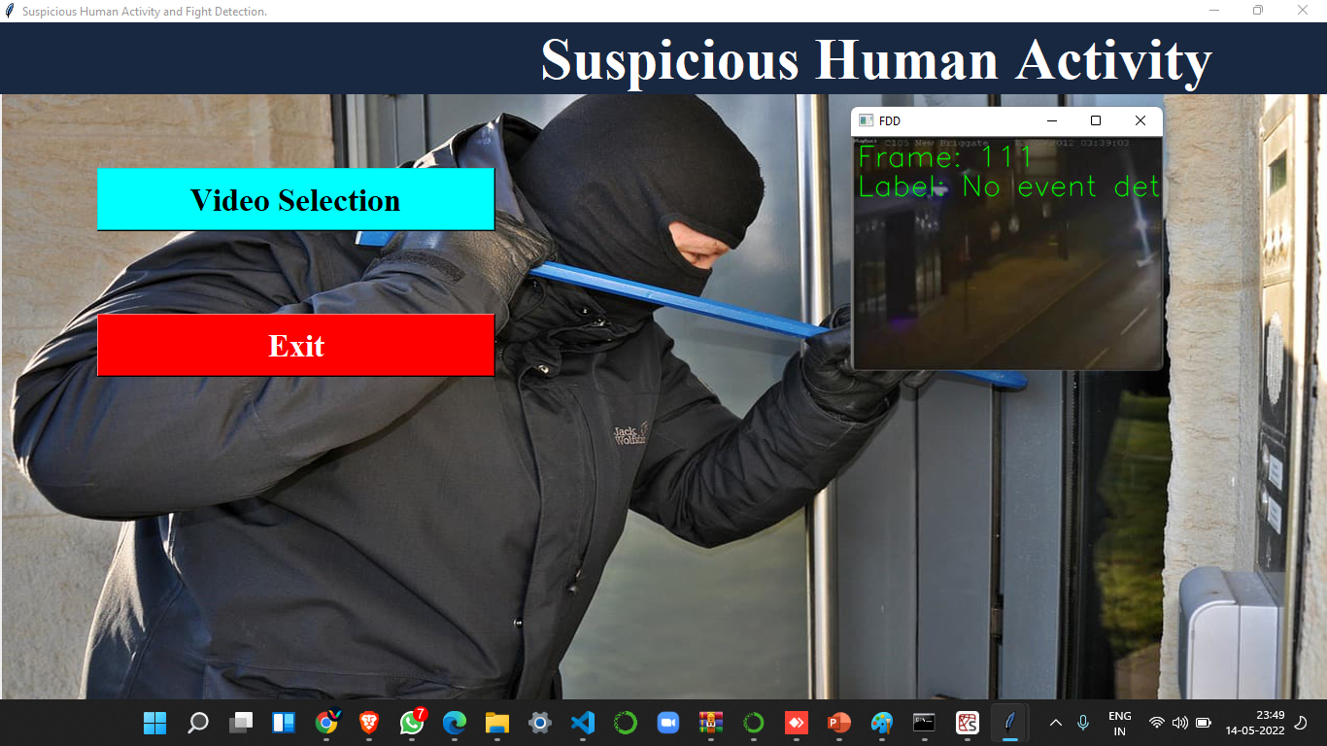

1. CONCLUSION

A project model is used to process real-time CCTV footage to detect any suspicious activity would help in creating better security and less human interface in Activities. Considerable progress has been made in the field of human suspicious activity, which enables us to better serve the applications possible with it. In addition, research in related areas such as activity can increase like trcking its productive use in many areas.

1. ACKNOWLEDGEMENTS

We get great satisfaction and pleasure from working on this “Human Suspicious Activity and Fight Detection using Deep Learning”. We are thankful to and fortunate enough to get constant encouragement, support, and guidance from our guide Prof. Sunita Vani. She encouraged us to keep moving forward under his guidance and watchful support. We also want to thank all the friends who inspired us when we hit a wall.

1. FUTURE SCOPE

In our model we take number of images form video if video is large then it will take more time to create frames. In future we try to improve accuracy and make sure that it takes less time to capture human suspicious activity. In future we will add more images data set to detect suspicious activity and Fight.

1. REFERENCES
2. In paper [1] Real-Time suspicious Detection and Localization in Crowded Scenes. [Mohammad Sabokrou , Mahmood Fathy]
3. In paper [2] Learning Temporal Regularity in Video Sequences. [Mahmudul Hasan

Jonghyun Choi]

1. In paper [3] suspicious Detection in Video Using Predictive Convolutional Long Short-Term Memory Networks [Jefferson Ryan Medel]
2. In paper [4] Abnormal Event Detection in Videos using Spatiotemporal Auto encoder. [Yong Shean Chong]
3. In paper [5] Unrolled Optimization with Deep Priors. [Steven Diamond Vincent Sitzmann]
4. In paper [6] A Revisit of Sparse Coding Based Suspicious Detection in Stacked.